Governance, Oversight, and Accountability Plan
CORE Program
Project Management Office  February 2019 |  | 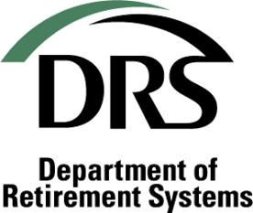
TABLE OF CONTENTS
Overview 4
Purpose 4
Program Description 4
Approach 5
Organizational Program Structure 5
DRS Roles and Responsibilities for Decision-Making 6
Program Advisor 9
Project Oversight 9
Responsiblity 10
Responsibility Assignment Matrix (RACI Chart) 11
Accountability 12
Program and Project Management 12
Meetings 12
Reports 12

Version History:

Version | Date | Additions/Modifications | Revised By
1.0 | 11/5/2018 | Approved By Executive Steering Committee
2.0 | 2/6/2019 | Updated program structure based on resources in the Governor’s Budget | Grace Edwards and Amy McMahan
2.5 | 6/5/2020 | Updated program structure to include Sponsors for CORE Planning 21-23 | Rachel Nesse and Amy McMahan

Overview

Purpose
The role of project governance is to provide a decision-making framework that is logical, robust and repeatable to govern an organization’s investments.
This Governance, Oversight and Accountability (GOA) Plan provides guidance to individual team members and stakeholders on who and how the Department of Retirement Systems (DRS) governs and oversees the Department of Retirement Systems’ Creating an Outstanding Retirement Experience (CORE) Program.
The GOA document provides an overall framework for governance that serves as an umbrella document over each of the projects within the CORE Program.
The audiences of this document include DRS Leadership Team, DRS project managers, project quality oversight resources, vendors, project team members and other DRS team members.

Program Description
The CORE Program is a multi-year, multi-project effort that will include both technology enhancements and business process re-design. Below are the defined vision, goals, and technology principles that will guide this CORE Program across the various projects.

Program Vision
To establish modern technology systems and tools that strengthen our team members’ capability to deliver value-added services to DRS customers, partners, stakeholders and policymakers.

Program Goals
In alignment with DRS’s key goals, the long-term goals of the CORE Program are to:
- Adopt updated core business processes that support an excellent customer experience (Elated Customers)
- Enhance DRS team member experience by modernizing core technology to support our pursuit of 100 percent customer satisfaction (Engaged Team Members)
- Reduce risk of our core technology (Vigilant Resource Stewards)

Technology Principles
The Program will consider technology solutions that are:
- Secure
- Standardized
- Modular/reusable
- Reliable
- Scalable/Flexible

Approach
An Executive Sponsor and a Project Director oversee the CORE Program and its related projects. The Executive Steering Committee (ESC) provides strategic direction for the project and ensures project resources are available to the CORE Program. The Project Director provides guidance and makes resource allocation decisions within the CORE Program based on the ESC’s direction.
The DRS Director is the Executive Sponsor, and has ultimate accountability for the success of the CORE Program. However, there are multiple layers of accountability for the execution and management of the project.
The DRS Project Management Office Director is the Program Director, and has accountability for day-to-day management of the CORE Program. Assignments have been identified and recorded in a Responsibility Assignment Matrix that clarifies roles, responsibilities, and decision-making authority. This matrix is provided later in this document.

Organizational Program Structure
The diagram below illustrates how the CORE program is organized and how each project fits into the overall governance and oversight efforts. This diagram is a visual representation to communicate the hierarchy and escalation path for reporting, approvals, and substantive changes in budget, resources, scope, and schedule.
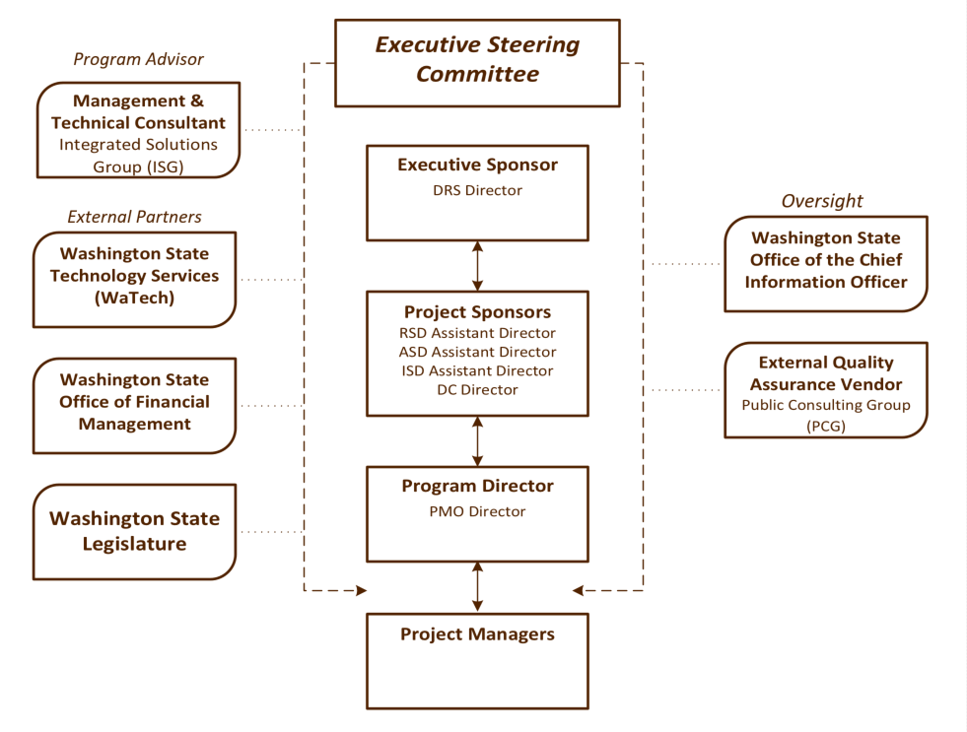

DRS Roles and Responsibilities for Decision-Making
DRS, has authorized the entities included in this section to provide oversight and leadership to the CORE Program. These active decision-making bodies review project objectives and outcomes, funding and budget issues, resource needs and priorities.

Executive Sponsor
The Executive Sponsor oversees the program and is ultimately accountable for the program’s success. This role ensures that program and project objectives are well defined, achievable and aligned with the agency’s strategic direction. This person is the executive decision-maker. This role is responsible for leadership and advocacy for the program both within DRS and with external stakeholders.

Executive Steering Committee (ESC)
The ESC is made up of the Executive Sponsor, Project Sponsors, and Program Director. The ESC provides strategic direction for and ensures resources are available to the CORE Program. The ESC will:
Provide support to the CORE Program by:
- Guiding CORE Program direction and design
- Authorizing resources (budget and people)
- Advocating for the program/projects both internally and with external stakeholders
- Leading the adoption of new business process and technology with their respective areas of responsibility and bringing about organizational changes that may arise from this program
- Communicating expectations and anticipated outcomes to team members
- Serving as change leaders for business transformation
- Removing barriers to program/project success when needed
- Prioritizing competing interests between operational needs and program/project needs where required
Ensure:
- Overall success of the Program
- CORE Program supports' strategic business goals
- CORE Program goals and objectives reflect agency priorities
- Scope is clearly defined and managed
- Issues escalated are addressed timely
Approve:
- Major strategic or policy decisions
- Agency investment plan
- Substantive changes to scope, budget or schedule

Project Sponsors
A Project Sponsor is assigned to each project within the CORE Program. These individuals provide guidance and direction to the individual projects within the CORE Program that they sponsor. These sponsors will make decisions as needed and will work with the Program Director to identify issues that need to be escalated. Project decisions will include all escalated decisions except for decisions regarding strategic direction of the CORE program, or significant changes to scope, schedule, or budget. Sponsors will:
Ensure:
- Project priorities are established that support business needs
- Issues about project direction are escalated to the Executive Sponsor if they cannot be resolved by the Project Sponsors
- Decisions are made timely when needed
Work with the Project Director to:
- Meet resource needs
- Remove project barriers
- Manage competing priorities
Approve:
- Key project documents (project plans, schedules, change management plans, etc.)
- CORE Program status reports
- Contract procurement materials
- Vendor contracts

Program Director
The Program Director provides day-to-day oversight of the CORE Program and its related projects. This position has responsibility for the execution of the projects in the CORE Program. This role communicates up to the Executive and Project Sponsors and is responsible for coordination with the State OCIO and external quality assurance. This role is responsible for the development and execution of overall program management processes and activities and managing issues and risks across all projects in the Program. The role also sets direction and provides guidance and support for tactical implementation activities. This Program Director will also:
Ensure:
- Escalated issues and risks are appropriately mitigated, escalated, or resolved
- Projects are coordinated with other program area plans and projects
- Decisions are escalated timely as needed
- Vendors are performing in accordance with their established contracts
- Consistent use of project tools across the CORE Program
- Project Managers have resources, tools and technology for project success
- Individual projects are executing within budget, scope, and schedule

Monitor:
- Program and project management processes
- Change management processes
- Project status
- Project metrics-scope, budget, schedule and resources
Manage:
- Competing priorities of the CORE Program
- Assigned project resources across the CORE Program
- Project management processes

Work with the Project Sponsors and Project Managers to:
- Identify, recruit and retain skilled project resources
- Acquire appropriate tools and technology
- Remove project barriers
- Manage competing priorities
Approve:
- Key project documents (project plans, schedules, change management plans, etc.)
- CORE Program and project status reports
- Contract deliverables

Project Manager(s)
The project managers are responsible for the day-to-day project decisions related to the execution of the assigned projects within the defined scope, budget or timeline. The Project Manager will:
- Develop and manage project deliverables (project charter, project plan, schedule, and issue and risk logs)
- Coordinate project team assignments, and allocate resources within the project
- Manage projects issues and risks within the project
- Mange project vendor performance.
- Manage project resources.
- Escalate issues, risks, resource constraints and other decisions timely and as needed
- Escalate any decision that may impact or exceed the scope, budget or timeline of the project or any decision that will negatively impact quality or business value of the project
- Prepare monthly status reports including project metrics- scope, budget, schedule and resources
- Present to ESC as to external oversight entities as needed.

Program Advisor: Technical and Management Consultant
The Technical/Management Consultant will provide qualified, senior level staff that will provide valuable insights based on IT project experience on Washington State projects and will provide DRS leadership with advice, technical knowledge, and management consulting services. The consultant will support DRS in making key decisions by preparing and refining project artifacts, conducting analysis and market research, and drafting other key documents (such as decision packages, presentations, etc.)

Project Oversight
The primary governance responsibility for project oversight entities is to ensure the project successfully achieved its objectives. These entities work directly with and meet regularly with the Project Director to provide input and oversight.

OCIO Project Oversight
The Office of the Chief Information Officer (OCIO) sets information technology (IT) policy and direction for the State of Washington. The State CIO is a member of the Governor’s Executive Cabinet and advisor to the Governor on technology issues. The OCIO oversees state projects by evaluating project business case, project readiness, and alignment with the state’s enterprise technology strategies.
The OCIO also requires that necessary information - including the agency investment plan, regular status reports, and quality assurance reports and responses - about this Program are centrally stored for information, reporting and planning purposes on the IT Project Dashboard. DRS is required to obtain approval from the OCIO’s office for the agency’s investment plan in advance of major technology investments. The OCIO also provides guidance support and oversight to ensure quality outcomes.

DRS Quality Assurance Vendor
The primary responsibility of the external quality assurance (QA) vendor is to ensure that the project successfully achieves its objectives while following project standards. The QA vendor will advise DRS on best practices and lessons learned from other projects. QA will provide a monthly status report that describes the project’s current quality assurance status and risk assessment based on their observations of the project. QA will conduct document review and participate in project meetings as needed to maintain visibility into the project.
Note: Independent Verification and Validation will be used in project work streams as appropriate and may be a part of the QA vendor’s responsibilities.

Decision Making Framework
Below is a diagram that depicts who has what decision-making responsibilities within the CORE Program. A decision log will be maintained for the CORE Program and each Project within it. All decisions escalated to the Project Sponsors or Executive Sponsor must be documented using DRS’s decision-statement format or an alternative format approved by the Executive Steering Committee.

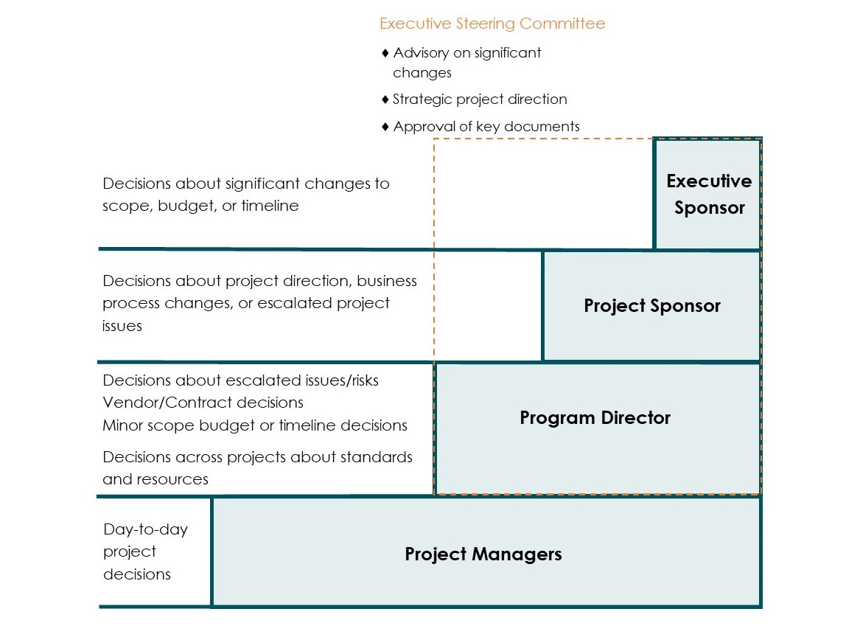

RESPONSIBILITY
As an additional means of confirming roles and responsibilities for the CORE Program, a Responsibility Assignment Matrix is provided for key decision points. This matrix, also referred to as a RACI (Responsible, Accountable, Consulted or Informed) Chart with each letter describing the level of participating required for each project role. The RACI chart provides improved communication and decision-making efficiency and reduces conflict.
The definitions of each level of participation are:
Responsible: The position(s) who do the work to achieve the task
Accountable: The position who is ultimately responsible for the accuracy of the task and who delegates the work to those responsible.
Consulted: The position(s) whose opinions are sought and with whom there is two-way communication.
Informed: The position(s) who are kept up-to-date on progress, often on completion of a task or deliverable and with whom there is just one-way communication.

Responsibility Assignment Matrix (RACI Chart)

Description/Task | Executive Sponsor | Executive Steering Committee | Project Sponsor | Program Director | Project Managers
Budget Funding and Changes | A | C | C | R | R
Scope Definitions and Changes | A | C | C | R | R
Initial Schedule and Changes | A | C | C | R | R
Program Communication | I | C | C | A | C
Project Communication | I | C | C | A | R
Organizational change leadership | C | R | C | A | R
Resource Planning and Acquisition | I | C | C | A | R
Project Charter(s) | A | C | C | R | R
Investment Plan | A | C | C | R | C
Project Metrics | I | C | C | A | R
Program Deliverables | I | C | C | A, R | C
Project Deliverables | I | C | C | A | R
Procurement Processes | I | C | C | A | R
Vendor Management | I | C | C | A | R
Change Control Processes | I | C | C | A | R
Policy or Technical Clarifications | C | I | R | A | C
Program Risks and Issues | I | C | C | A, R | C
Project Risks and Issues | I | C | C | A | R
QA Status Reports and Issue Resolution | A | I | C | R | C
IV&V Status Reports and Issues Resolution (as needed) | A | I | C | R | C

Accountability
As the Executive Sponsor, the DRS Director has ultimate accountability for the success of the CORE Program. However, similar to the governance and oversight functions described earlier, there are multiple layers of accountability related to the execution and management of the project. The CORE Program has appropriated disciplines (e.g., project management standards, quality control, status reporting, budget/schedule variance reporting, risk and issue tracking) to monitor, support and manage overall project performance. These disciplines include:

Program and Project Management
The CORE Program will use Project Management Institute’s PMI Standards as described in the Project Management Body of Knowledge (PMBOK). The projects within the CORE Program will use either a traditional (waterfall) project methodology or a hybrid (waterfall/agile) project methodology, ensuring that advantages of each are incorporated into the project to encourage flexibility, effective risk management, and delivery of value throughout the project.

Meetings
The CORE Program will host the following meetings:
- Weekly meetings with the CORE Project Managers and the Program Director
- Weekly project team meetings, which includes the review of the project status, risks, and issues.
- Bi-weekly, or if required, more frequent Project Sponsor meetings for each project
- Monthly, or if required, more frequent Executive Sponsor Committee meeting for the whole CORE Program
- Periodic meetings with the OCIO and external QA vendors

Reports
A variety of reports will be produced to support consistent project management and oversight. The reports will include:
- Regular project status reports for each CORE project that includes any updates on issues and risks
- Monthly QA assurance reports
- As needed, QA response reports
- Monthly IV&V reports when applicable

