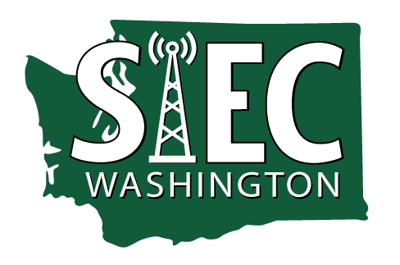 |  | AGENDA  State Interoperability Executive Committee  Hybrid Meeting  August 8, 2023 | 10:00 AM – 12:00 PM  Location:  1500 Jefferson St. SE, Olympia, WA 98504 | 1st Flr Conf Rm 1213  or  Join Zoom Meeting  Join by phone 1-253-215-7799 | Access code: 999 6052 5038#
Separate documents or attachments are also found on this website.
Refers to decisions required.

10:00-10:05  10:05-10:25 | Time for Zoom log-in and Test audio  Call to Order, Welcome, and Introductions  - Review agenda  - News and Information Roundtable  - Approval of June 13 meeting minutes |  | Bill Kehoe, Chair  SIEC Members
10:25-10:35 | Introduction and Brief FirstNet Update |  | Brett Johnson, FirstNet
10:35-10:55 | Cybersecurity Grant Updates - Applications |  | Zack Hudgins, Vice-Chair
10:55-11:00 | SAW Group Updates |  | Anton Damm, SAW Chair
11:00-11:30 | SCIP  - SCIP Addition -  - Assign Objectives to Subcommittee or SAW Group?  - Potential Decision Package for SIEC |  | Bill Kehoe and Members
11:30 | Good of the Order and Public Comments |  | All

