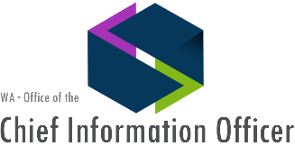
Washington Master Addressing Services (WAMAS)
Existing Users of WAMAS
County Users of WAMAS
Thurston Co. Regional Planning – using it for public mail outs to expedite the process & reduce duplicate mailing addresses.
Thurston Co E911 –validating addresses to build zip code mapping for emergency dispatch
Franklin Co E911 – validating addresses & finding accurate location of home for E-911 dispatch
Benton Co E911– validating addresses & finding accurate location to aid in E-911 dispatch
Clallam Co -
Lewis Co – identify & assign addresses and for address location for e-911
Stevens Co. – Address cleaning
Clark Co -

State Users of WAMAS
ATG - consistent & accurate mapping of Consumer Complaints
HCA -via Secured DSHS connection – validates addresses from applicants for health insurance
DES
Leg Services –validate addresses before constituents can email their legislators
LNI - researchers are geocode sets of addresses for research projects
DEL -
ECY – processing addresses for local grants and permits & notification of air pollution warnings
OFM – for population estimates & facilities management
DOH – Birth & Death Records processing and epidemiology
DOH (contractor) online application process for health profession & facility credential apps
DFW – Facilities mgmt. -- visit, document and monitor the assets and human resources
DFW (contractor) Go Hunt & Go Fish public apps and Hydrologic Project Approvals
DSHS –
PDC -
DOR – validation of business, streamline taxing, ATLAS implementation
WaTech – Voter Pool established for counties & BIZHUB considering
WSRB –
SOS - Corporations and Charities Filing System Project

WAMAS Cost $189,000 / Year to operate Customers agencies save over $600,000 / Year
4/2017

