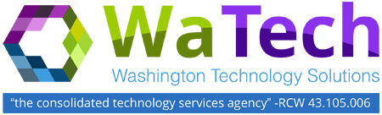

ADVISORY COUNCIL MEETING

Tuesday, May 23, 2017
Washington Technology Solutions
1500 Jefferson St SE, Room 2331 / Olympia
10:30 a.m. – 12:00 p.m.
AGENDA

# | TOPIC | LEAD | ACTION / NOTES | TIME ALLOTED | ESTIMATED TIME STAMP
1 | Welcome | Heidi Geathers | Introduction/Updates | 5 MINUTES | 10:30-10:35
2 | Finance Update | Wendi Gunther | Update/Discussion | 20 MINUTES | 10:35-10:55
3 | Mainframe Update | Pasha Naini/  Lance Calisch | Update/Discussion | 20 MINUTES | 10:55-11:15
4 | Security Trends | Agnes Kirk | Discussion | 20 MINUTES | 11:15-11:35
5 | Security Trends – Q&A | Agnes Kirk | Q&A | 10 MINUTES | 11:35-11:45
6 | Agenda Input for the  July Meeting | Heidi Geathers | Discussion | 15 MINUTES | 11:45-12:00

