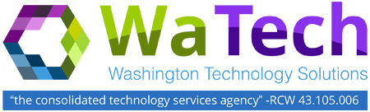
ADVISORY COUNCIL MEETING

Tuesday, July 25, 2017
Washington Technology Solutions
1500 Jefferson St SE, Room 2331 / Olympia
10:30 a.m. – 12:00 p.m.
AGENDA

# | TOPIC | LEAD | ACTION / NOTES | TIME ALLOTED | ESTIMATED TIME STAMP
1 | Welcome | Heidi Geathers | Introduction/Updates | 5 MINUTES | 10:30-10:35
2 | Finance update | Wendi Gunther | Update | 15 MINUTES | 10:35-10:50
3 | Open Data vs Security:  What is the right balance? | Alex Alben | Discussion | 20 MINUTES | 10:50-11:10
4 | Security Allocation:  What does that cover? | Heidi Geathers | Discussion | 15 MINUTES | 11:10-11:25
5 | Update on ISG report (Mainframe) | Heidi Geathers | Update | 15 MINUTES | 11:25-11:40
6 | Agenda input for the  September meeting | Heidi Geathers | Discussion | 20 MINUTES | 11:40-12:00

