Customer: Click here to enter text. Site: Click here to enter text.

Turn-up Testing
- There are 4 SSID’s that should be broadcasting. Are you able to see all 4 SSID’s?
<Local Agency> | ☐ | Yes | ☐ | No | ☐ | N/A
Roaming | ☐ | Yes | ☐ | No | ☐ | N/A
Sponsored Guest | ☐ | Yes | ☐ | No | ☐ | N/A
Guest | ☐ | Yes | ☐ | No | ☐ | N/A
- Connect to the Guest SSID on your computer and open your web browser and navigate to a website . Were you prompted to accept the Acceptable Use Policy?
☐ | Yes | ☐ | No | ☐ | N/A
- While connected to the Guest SSID select accept on the AUP page and navigate to an external website. Was this successful?
☐ | Yes | ☐ | No | ☐ | N/A
- Connect to the local agency SSID and navigate to a few external websites. Was this successful?
☐ | Yes | ☐ | No | ☐ | N/A
- While connected to the <Local Agency> SSID, try and connect to local resources like a network drive. Was this successful?
☐ | Yes | ☐ | No | ☐ | N/A
- Connect to the Roaming SSID and navigate to a few external websites. Was this successful?
☐ | Yes | ☐ | No | ☐ | N/A
- While connected to the Roaming SSID, try and connect to local resources like a network drive. Was this successful?
☐ | Yes | ☐ | No | ☐ | N/A
- Log into the Sponsored guest portal Here and login with your standard Windows credentials. Was this successful?
☐ | Yes | ☒ | No | ☐ | N/A
- At the top of the page select Create Account as shown in the figure below. Fill out all of the fields then select create. You will need to click Notify after clickeing create and add your email, you should get an email for the newly created account. Was this successful?
☐ | Yes | ☐ | No | ☐ | 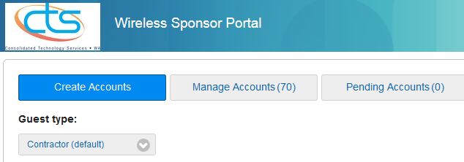  N/A

- Try logging into the Sponsored Guest SSID with the new credentials that you received in the email. Was this successful?
☐ | Yes | ☐ | No | ☐ | N/A
- Log into Prime by clicking Here and enter the credentials provided by WaTech wireless team. Was this successful?
☐ | Yes | ☐ | No
- After logging into Prime navigate to Maps>Site Maps. Do you see your floor maps for the sites in your virtual domain?
☐ | Yes | ☐ | No
- In Prime navigate to Monitor>Network Devices>Device type>unified AP. Do you see your agency’s access points?
☐ | Yes | ☐ | No
- If you have access points in FlexConnect mode, connect to your agency SSID and try a tracert to Google. Is the traffic taking the correct network path?
☐ | Yes | ☐ | No | ☐ | N/A
This section to be completed by WaTech Wireless Technician
Turn-up Comments: Click here to enter text.
Turn-up Date: Click here to enter a date.
Billing *Start Date: Click here to enter a date.
*Sites turned up between the 1st and 15th of the month will begin billing on the 1st of the month. Sites turned up between the 16th and 31st of the month will begin billing on the 1st of the following month.

